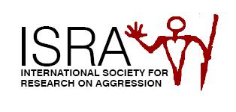
International Society for Research on Aggression

Membership Certificate (2024)

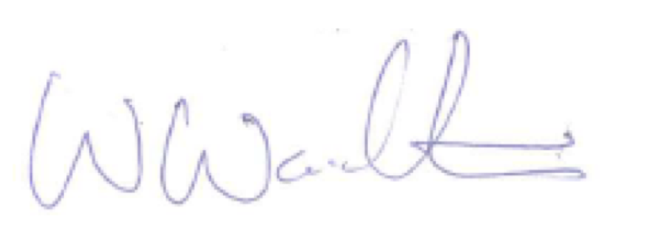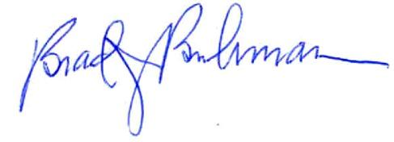
Wayne Warburton Brad J. Bushman
ISRA President ISRA Executive Secretary

